LAB PROGRAMS
Day 6- 23/01/2026
Name: K. Guna Shekar Reddy
Register Number: 192424323
Course: CSA0412-Fundamentals of Data Science for Data Analytics

Experiment 29
import pandas as pd
from sklearn.datasets import load_breast_cancer
from sklearn.model_selection import train_test_split
from sklearn.linear_model import LogisticRegression
from sklearn.metrics import accuracy_score, precision_score, recall_score, f1_score

data = load_breast_cancer()
df = pd.DataFrame(data.data, columns=data.feature_names)
df["target"] = data.target
print("\nAvailable Features:")
print(list(df.columns))
features_input = input("\nEnter feature names separated by comma: ")
target_input = input("Enter target variable name: ")
features = [f.strip() for f in features_input.split(",")]
X = df[features]
y = df[target_input]
X_train, X_test, y_train, y_test = train_test_split(
X, y, test_size=0.3, random_state=42
)
model = LogisticRegression(max_iter=500)
model.fit(X_train, y_train)
y_pred = model.predict(X_test)
accuracy = accuracy_score(y_test, y_pred)
precision = precision_score(y_test, y_pred)
recall = recall_score(y_test, y_pred)
f1 = f1_score(y_test, y_pred)
print("\nModel Evaluation Metrics:")
print("Accuracy :", accuracy)
print("Precision:", precision)
print("Recall :", recall)
print("F1-score :", f1)

Output:
Available Features:
['mean radius', 'mean texture', 'mean perimeter', 'mean area', 'mean smoothness', 'mean compactness', 'mean concavity', 'mean concave points', 'mean symmetry', 'mean fractal dimension', 'radius error', 'texture error', 'perimeter error', 'area error', 'smoothness error', 'compactness error', 'concavity error', 'concave points error', 'symmetry error', 'fractal dimension error', 'worst radius', 'worst texture', 'worst perimeter', 'worst area', 'worst smoothness', 'worst compactness', 'worst concavity', 'worst concave points', 'worst symmetry', 'worst fractal dimension', 'target']

Enter feature names separated by comma: mean radius,mean texture,mean smoothness
Enter target variable name: target

Model Evaluation Metrics:
Accuracy : 0.9181286549707602
Precision: 0.9196428571428571
Recall : 0.9537037037037037
F1-score : 0.9363636363636364
Experiment 32
Program:
import pandas as pd
import matplotlib.pyplot as plt
from sklearn.model_selection import train_test_split
from sklearn.linear_model import LinearRegression
from sklearn.metrics import mean_squared_error, r2_score

df = pd.read_csv("house_prices.csv")
print("Dataset Preview:")
print(df.head())
plt.figure()
plt.scatter(df["HouseSize"], df["Price"])
plt.xlabel("House Size (sq ft)")
plt.ylabel("House Price")
plt.title("Bivariate Analysis: House Size vs Price")
plt.show()
X = df[["HouseSize"]]
y = df["Price"]
X_train, X_test, y_train, y_test = train_test_split(
X, y, test_size=0.2, random_state=42
)
model = LinearRegression()
model.fit(X_train, y_train)
y_pred = model.predict(X_test)
mse = mean_squared_error(y_test, y_pred)
r2 = r2_score(y_test, y_pred)
print("\nModel Evaluation:")
print("Mean Squared Error (MSE):", mse)
print("R-squared (R² Score):", r2)

plt.figure()
plt.scatter(X, y, label="Actual Data")
plt.plot(X, model.predict(X), color="red", label="Regression Line")
plt.xlabel("House Size (sq ft)")
plt.ylabel("House Price")
plt.title("Linear Regression: House Price Prediction")
plt.legend()
plt.show()

Output:
Dataset Preview:
HouseSize Price
0 800 120000
1 900 135000
2 1000 150000
3 1100 165000
4 1200 180000
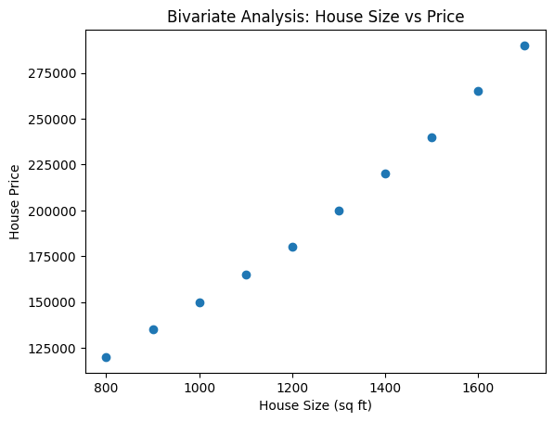
Model Evaluation:
Mean Squared Error (MSE): 19245132.28299631
R-squared (R² Score): 0.9954449391046163
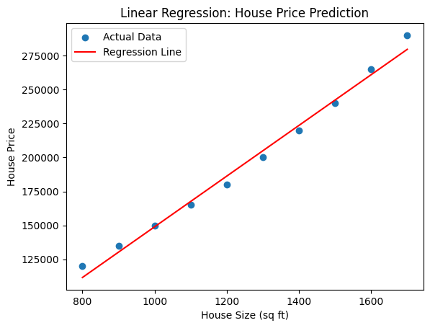

Experiment 34
Program:
import pandas as pd
from sklearn.model_selection import train_test_split
from sklearn.preprocessing import LabelEncoder, StandardScaler
from sklearn.neighbors import KNeighborsClassifier
from sklearn.metrics import accuracy_score, precision_score, recall_score, f1_score

df = pd.read_csv("medical_data.csv")
le_gender = LabelEncoder()
le_outcome = LabelEncoder()
df["Gender"] = le_gender.fit_transform(df["Gender"])
df["Outcome"] = le_outcome.fit_transform(df["Outcome"])
X = df[["Age", "Gender", "BloodPressure", "Cholesterol"]]
y = df["Outcome"]
X_train, X_test, y_train, y_test = train_test_split(
X, y,
test_size=0.3,
random_state=42,
stratify=y
)
scaler = StandardScaler()
X_train = scaler.fit_transform(X_train)
X_test = scaler.transform(X_test)
knn = KNeighborsClassifier(n_neighbors=1)
knn.fit(X_train, y_train)
y_pred = knn.predict(X_test)
accuracy = accuracy_score(y_test, y_pred)
precision = precision_score(y_test, y_pred, zero_division=0)
recall = recall_score(y_test, y_pred, zero_division=0)
f1 = f1_score(y_test, y_pred, zero_division=0)
print("\nModel Performance Metrics:")
print("Accuracy :", accuracy)
print("Precision:", precision)
print("Recall :", recall)
print("F1-score :", f1)

results = pd.DataFrame({
"Actual": le_outcome.inverse_transform(y_test),
"Predicted": le_outcome.inverse_transform(y_pred)
})
print("\nTest Set Predictions:")
print(results)

Output:
Model Performance Metrics:
Accuracy : 0.6666666666666666
Precision: 1.0
Recall : 0.5
F1-score : 0.6666666666666666

Test Set Predictions:
Actual Predicted
0 Bad Bad
1 Good Bad
2 Good Good

Experiment 23
Program:
import pandas as pd
import numpy as np
import matplotlib.pyplot as plt
from scipy import stats

df = pd.read_csv("clinical_trial_data.csv")
print("Dataset Preview:")
print(df.head())
placebo = df[df["Group"] == "Placebo"]["Outcome_Score"]
treatment = df[df["Group"] == "Treatment"]["Outcome_Score"]
t_stat, p_value = stats.ttest_ind(treatment, placebo)
print("\nT-statistic:", t_stat)
print("P-value:", p_value)
alpha = 0.05
if p_value < alpha:
print("Conclusion: Statistically significant difference (Reject H0)")
else:
print("Conclusion: No statistically significant difference (Fail to reject H0)")
means = [np.mean(placebo), np.mean(treatment)]
groups = ["Placebo", "Treatment"]
plt.figure()
plt.bar(groups, means)
plt.ylabel("Mean Outcome Score")
plt.title("Treatment vs Placebo Comparison")
plt.text(0.5, max(means) - 0.5, f"P-value = {p_value:.4f}", ha="center")
plt.show()

Output:
Dataset Preview:
Patient_ID Group Outcome_Score
0 1 Placebo 2
1 2 Placebo 3
2 3 Placebo 1
3 4 Placebo 4
4 5 Placebo 2

T-statistic: 9.428090415820634
P-value: 2.193184425990866e-08
Conclusion: Statistically significant difference (Reject H0)
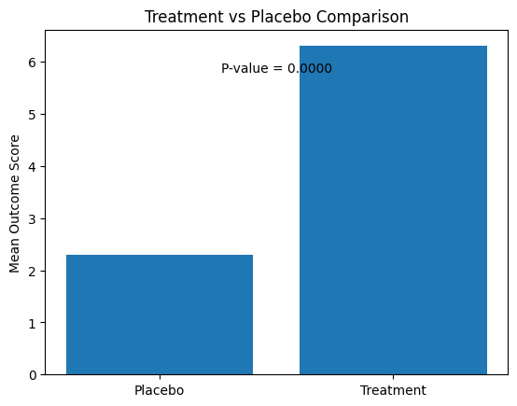

Experiment 24
Program:
import pandas as pd
from sklearn.neighbors import KNeighborsClassifier
from sklearn.preprocessing import StandardScaler

df = pd.read_csv("patient_symptoms.csv")
print("Dataset Preview:")
print(df.head())
X = df[["Fever", "Cough", "Fatigue"]]
y = df["Condition"]
scaler = StandardScaler()
X_scaled = scaler.fit_transform(X)
print("\nEnter symptoms for new patient (0 = No, 1 = Yes)")
fever = int(input("Fever (0/1): "))
cough = int(input("Cough (0/1): "))
fatigue = int(input("Fatigue (0/1): "))
k = int(input("Enter value of k (number of neighbors): "))
new_patient = pd.DataFrame(
[[fever, cough, fatigue]],
columns=["Fever", "Cough", "Fatigue"]
)
new_patient_scaled = scaler.transform(new_patient)
knn = KNeighborsClassifier(n_neighbors=k)
knn.fit(X_scaled, y)
prediction = knn.predict(new_patient_scaled)
if prediction[0] == 1:
print("\nPrediction: Patient HAS the medical condition")
else:
print("\nPrediction: Patient DOES NOT have the medical condition")

Output:
Dataset Preview:
Patient_ID Fever Cough Fatigue Condition
0 1 1 1 1 1
1 2 1 0 1 1
2 3 0 1 0 0
3 4 0 0 0 0
4 5 1 1 0 1

Enter symptoms for new patient (0 = No, 1 = Yes)
Fever (0/1): 1
Cough (0/1): 1
Fatigue (0/1): 0
Enter value of k (number of neighbors): 3

Prediction: Patient HAS the medical condition

